BROTHERS OF THE IMMACULATE CONCEPTION OF THE BLESSED VIRGIN MARY (BROTHERS FIC-GHANA PROVINCE)
PROVINCIAL DAY/FAMILY FEAST CELEBRATION, 21ST NOVEMBER, 2023.
VENUE: IN-SERVICE TRAINING CENTER, WA.
THEME: “DEEPENING OUR RELIGIOUS IDENTITY AS BROTHERS FIC IN THE 21ST CENTURY.”
On this day, 21st November, 2023, Brothers FIC-Ghana Province, on the feast of the presentation of the Blessed Virgin Mary, patroness of our congregation, marked its annual family feast on the above theme. It was a daylong celebration characterized by series of events that culminated into a Eucharistic Celebration in the evening. On this day, we commemorated the 183 years of existence of our Congregation, the 58th anniversary of FIC presence in Ghana and the Silver Jubilee of religious profession of Br. Felicio Timyang Gyeyir.
The celebration of the family feast was preceded by a workshop organized by the PC for all Brothers the previous day. The workshop was on the theme, “Corporate Governance and Ethical Investment.” The resource person gave a topnotch presentation and did justice to the topic.
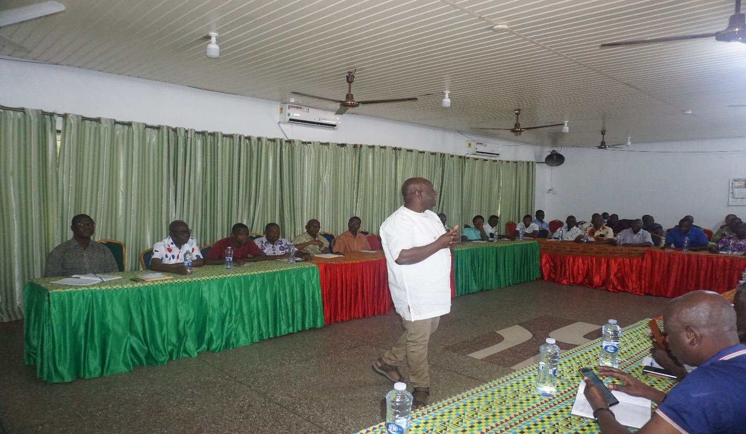
FIC workshop
Among other things, the day was also set aside to enable us have quality time together as one family, not only in formal discussions but also to recreate as well as celebrate our collective and individual achievements. In a very quiet and composed atmosphere in the morning, the brothers converged in the ISTC Chapel to kick start the much anticipated celebration in the context of an inspiring prayer service led by the liturgy committee on the above theme.
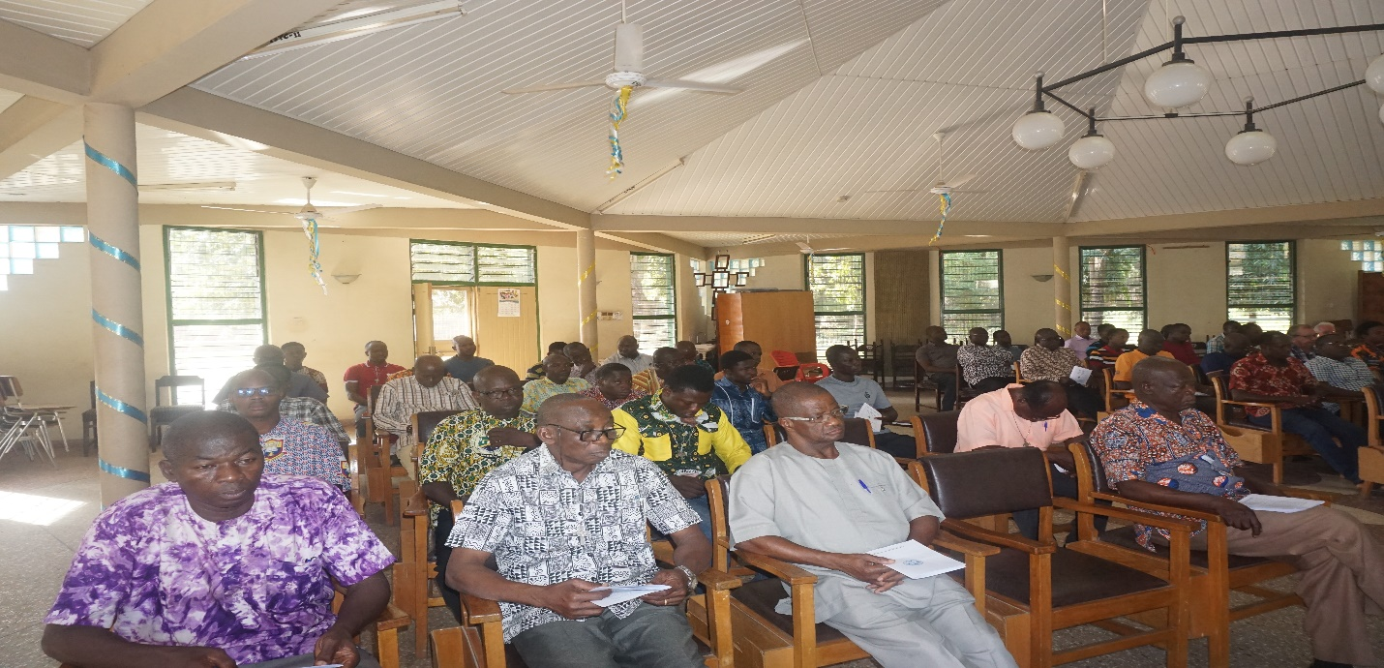
A cross-section of Brothers during the prayer service.
After the prayer service, the Brothers moved to one of the ISTC conference halls for the family meeting to begin. The Provincial Superior, Br. Seregeous Dery, welcomed the Brothers to the feast and entreated them to use the occasion to refresh themselves and renew our brotherly solidarity. Among other things, issues that are central to our lives were thoroughly discussed. The PC also seized the opportunity to keep brothers posted on general happenings in the Province.
After hours of fraternal deliberations, brothers went for lunch and observed a few minutes of siesta and came back for games/sports. The Sports Committee divided the Province into two geographical zones: the Sothern Zone locked horns with the Northern Zone in a thrilling volleyball competition.
In the evening, we climaxed the day with a Eucharistic Celebration in which we thanked God for all the favors and blessings bestowed on us throughout the year under review and implored his unfailing mercies for the following year. The Eucharistic Celebration was presided over by Very Rev. Fr. Cletus Kulah, Parish Priest of St. Cecilia’s Parish.
From the Chapel we proceeded to the forecourts of ISTC to crown the day with merrymaking. Br. Felicio was presented with gifts for having achieved a significant milestone in his religious profession. Brothers were also treated to a very good local music and dance by a bawa group. The local dance troops put up a thrilling performance that got other brothers on their feet.
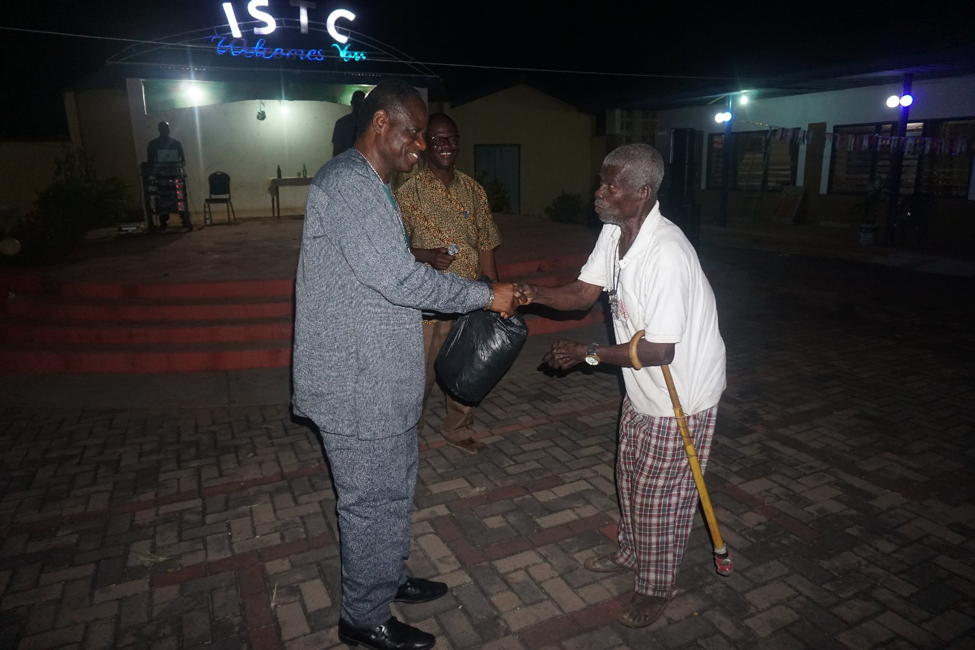
Br. Jerome making a presentation to Br. Felicio on the occasion of his Silver Jubilee.
In summary, the day was well marked and we remember Br. Felicio in particular for his sense of perseverance in service to God and humanity. We say bravo!
Br. Prosper Ganye

