BROTHERS FIC GHANA PROVINCE
FIRST SESSION OF THE PROVINCIAL CHAPTER 2018
18TH – 24TH FEBRUARY, 2018
THEME: DEEPENING OUR APOSTOLATE MISSION THROUGH PRAYER AND COMMUNITY LIFE.
The second day’s activities of the chapter commenced at 8.30am with a recollection on the theme: “Deepening our Apostolic Mission through Prayer and Community Life”, led by our able Facilitator, Rev. Fr. Edward Tengan, Director of the Pastoral and Social Institute, Wa.
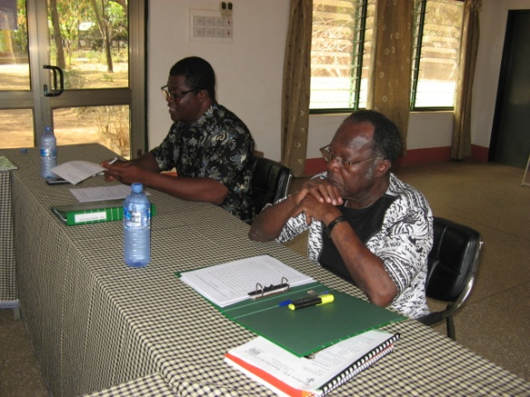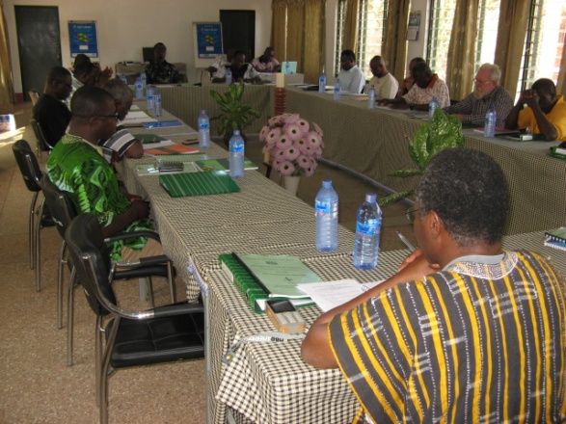
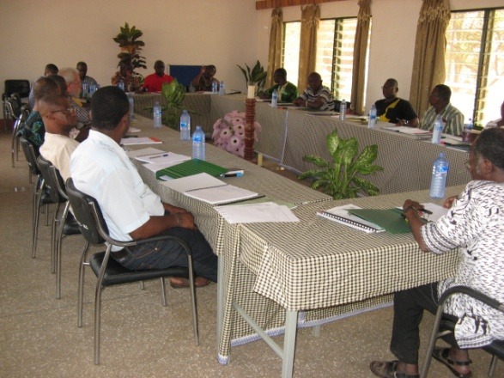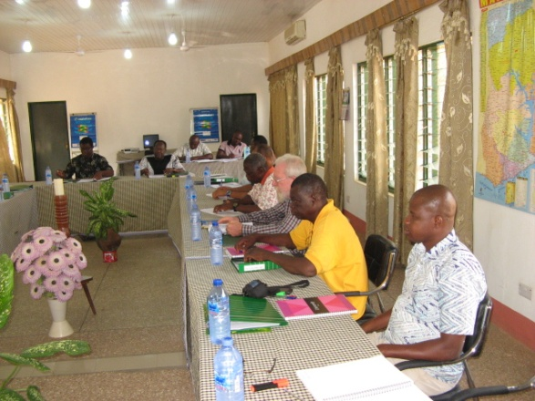
The recollection was centered on the following sub-topics: Introduction; The Trinitarian Base for Religious Life; Community Life; Community and Mission; and Conclusion. The facilitator ended the recollection with the following three thought provoking questions for meditation and personal reflection:
How have the three axes of religious life: union with God; union with others and communion with the church been lived out?
What is the way forward from where we find ourselves?
What sort of leadership do we need to shepherd us along the right path?
In the afternoon session (from 3.30 to 5.30pm) the brothers were divided into three groups to share the joys, worries and challenges of the province and write them down for further discussion in the larger group.
The day ended successfully with a Eucharistic celebration at 6.00pm.
By Bro. Fabian Kuupilleh
