FIRST PROFESSION OF RELIGIOUS VOWS-MALAWI PROVINCE
21st November is a memorable day for every brother in the family of Brothers FIC. This is when we remember and celebrate the foundation of the Congregation. It is also a day of the feast of presentation of the Blessed Virgin Mary. In Malawi Province, this is the day when most of the professions or jubilees are held to cement the day. In respect of our dear Mother, Mary and in appreciation of the very remarkable footprints that our founders left with us. They prayed and wished to see the congregation growing (both spiritual and in numbers).
This year 2023, Malawi Province had first profession on 18th November. For the past two years Malawi Province had had no professions and we thank God that finally, we have witnessed such big splendour. After few years of initial formation in both Malawi and Ghana, Novices Amos Kamwendo, Emmanuel Tambala and Charles Doviko made their first profession of religious vows in Mzedi. The celebration started with Eucharistic celebration which was presided over by the Bishop of Chikwawa Diocese, Most Rev. Fr Peter Musikuwa. In presence was the Vicar General of Blantyre Archdiocese, Fr. Boniface Tamani. The priests, religious brothers and sisters, families and friends of the novices and parishioners were also present. Mzedi joint Choir spiced up the event with soul-uplifting songs in jubilation of newly professed brothers.
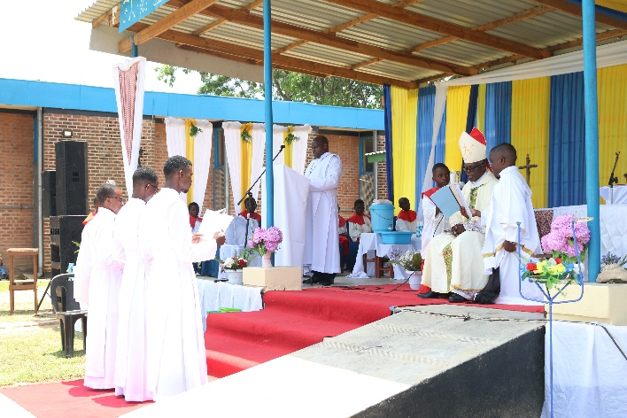
The Provincial Superior, Bro. Lawrence Sitima and Bishop Peter Musikuwa interrogating the new brothers during mass
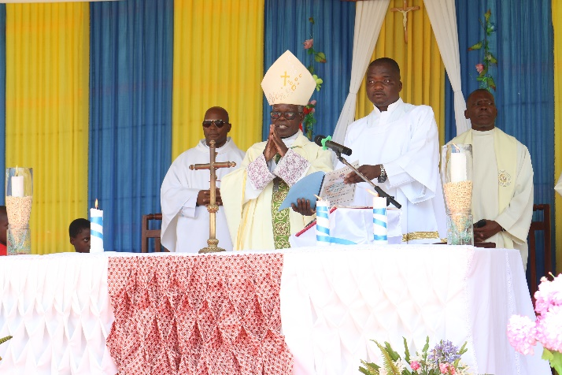
Bishop Peter Musikuwa presiding over mass.

Mass of the event started at 09:30 AM with a procession and all the brothers were part of it. The first reading was taken from Genesis (3:9-15.20) about the first sin of Adam and Eve, the second reading was taken from 2 Timothy (2:1-10) about the good soldier of Christ Jesus. The Gospel which was taken from Matthew (1:18-24) focused on the birth of Jesus, the Messiah, through the Blessed Virgin Mary. This is where much emphasis was made. The main celebrant stressed the need for FIC brothers to emulate the example of Mary, since she is part and parcel of their spirituality. To our newly professed brothers, the main celebrant advised them to look at Jesus Christ as their motivation and Mary as their model.
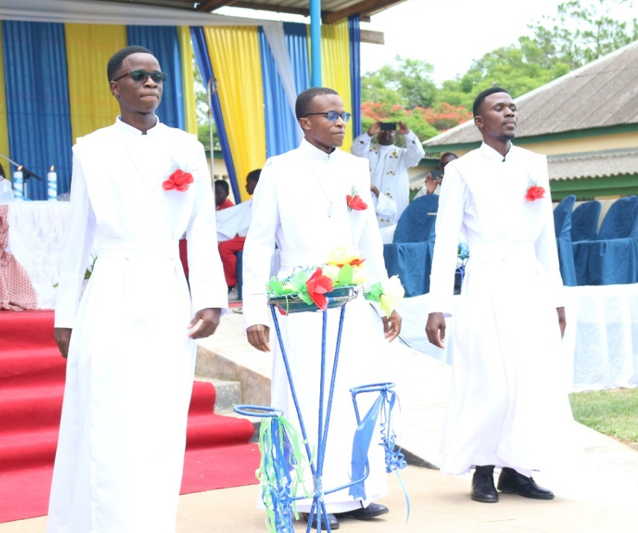
Brothers their first vows (from left: Bro. Amos Kamwendo, Bro. Charles Doviko and Bro. Emmanuel Tambala)
Looking at Christ as centre of our motivation was emphasized by the Bishop, the Vicar General and the Provincial Superior during their speeches. All speakers expressed the challenges that people face in different vocations of the church i.e. priesthood, religious life, married life etc. However, if one relies on prayer and puts faith in God, surely many good things will come his/her way. In summary, the Bishop said “faith in God does not prevent problems from coming our way but provides strength to endure them”. The Provincial Superior, Bro Lawrence Sitima, encouraged all the brothers to support the newly professed brothers in all aspects of their life as both persons and religious brothers FIC (to be good and do good towards them and others).
After the Eucharistic celebration, the Bishop, Priests, religious brothers and sisters, parents of newly professed brothers and invited guests were welcomed at the formation house for luncheon. The rest were served in the hall of St Patrick’s Secondary School.
Malawi Province is grateful to God for this positive development. This first profession is a sign of growth of the province. We implore Mary, patroness of our Congregation, to continue guiding the brothers in being faithful to their call, to be witnesses of God’s love for people, especially the vulnerable. We, equally, continue to be inspired by the same words of our founder from (1 Cor 3:10)"According to the commission of God given to me I laid the foundation. Let each man take care how he builds upon it”.

Compiled by Bro. Moses Mgunda
On behalf of Malawi Province

