2024 MALAWI PROVINCIAL CHAPTER
FIRST SESSION (22-24TH FEBRUARY)

DAY TWO REPORT (23ND FEBRUARY)
The second day of the chapter started with a Morning Prayer service at 07:00 AM, which was prepared by Maryview Community. The theme of the prayer service was “a new missionary approach” which is depicted from the main theme of “transformation and growth of the Malawi Province in the spirit of our founders”.
The prayer service dwelt on the two readings. Firstly, on the Acts 11:19-26 which categorizes the Christians of Antioch into two; those Greek-speaking of Jewish origin who had fled to Antioch from the persecuted Church in Jerusalem and those from Pagan background who after their contact with the Christian-Jews, became interested with Christianity. This placed the church in a dilemma as to whether those with Pagan background should be considered as second-class followers of Christ. Barnabas filled with the Holy Spirit, recognized God’s grace at work in them. Where the official church of Jerusalem hesitates, Barnabas reads the signs of the times. To him, it is God’s will that these people accept Christ as their Lord. He faces and solves the missionary problems locally and is not afraid to go new ways.
The other reading was taken from the Gospel of John 10:22-30. The reading describes the Jews who did not believe in Jesus Christ as a Son of God. There were able to witness the works of Jesus Christ but still asked for further signs and wonders. Jesus, rebukes them by saying only his sheep are able to hear his voice.
The two readings reflected the challenges that Brothers in Malawi province are facing. There are widening gaps among the brothers, issues of accountability and transparency. However, what is paramount is that we all accepted Christ and we should be responsible for the new changes in our life that comes with our desire to follow Jesus Christ. This is where the new missionary approach comes in, for we cannot preach the Christ we don’t live.

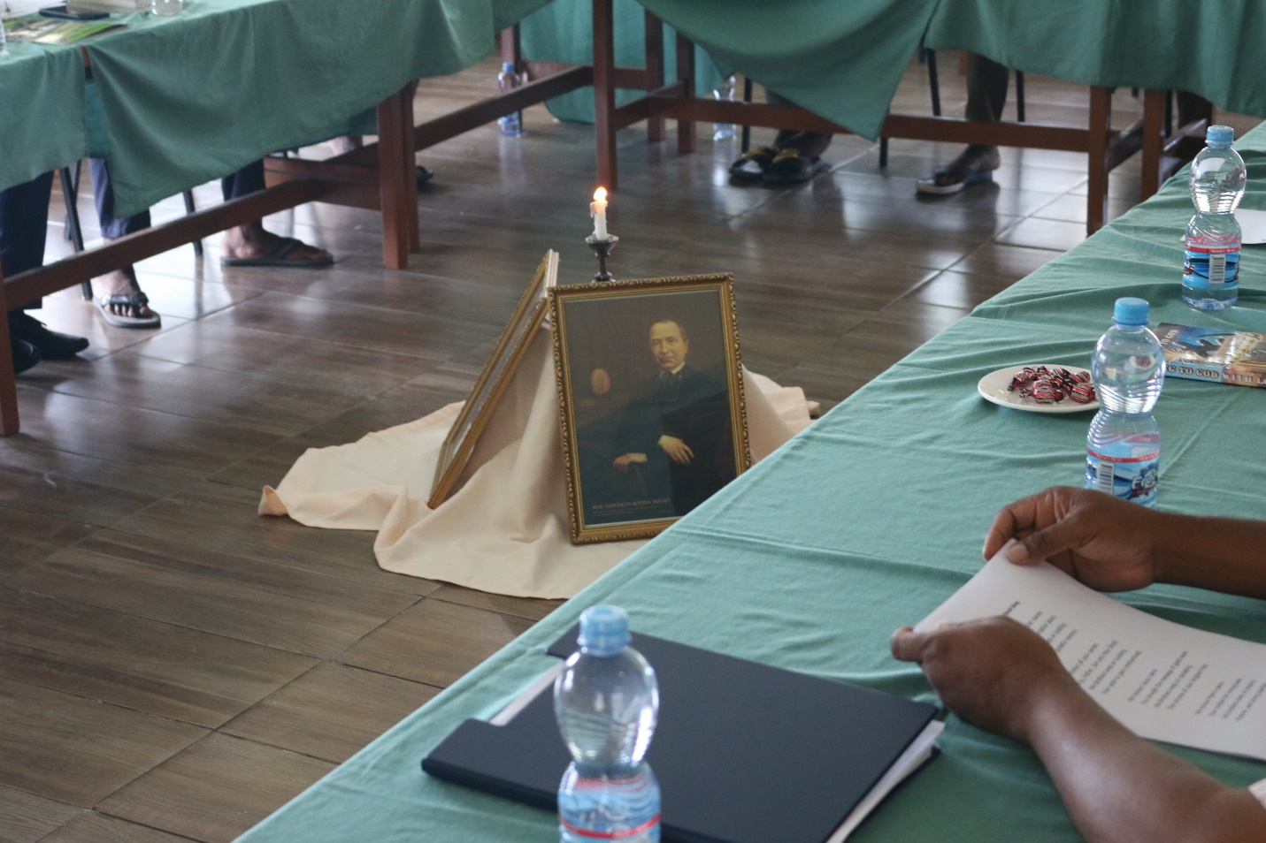
The two portraits of our founders and a burning candle on the middle of brothers

The first session of the day started at 08:30 AM with a Congregation hymn in honor of our Founders. Discussions during this session centered on Provincial report in connection with Apostolate in four communities of Malawi province (Bethel, Mzedi, Mitengo and Maryview) and also general report on finances. There was active and maximum participation on this exercise.
The afternoon session, focused on cross-examining the minutes from the secretariat. To see to it whether the minutes reflect the discussions of the chapter. Furthermore, the chapter members brainstormed on the proposals presented to them by expanding their horizon to have a clear understanding on the latter.

The day was concluded with a Eucharistic Mass around six o’clock in the evening. During the homily, more emphasis was made on the need for forgiveness and reconciliation among ourselves in as far as transformation and growth in the Province is concerned.
Real and genuine transformation is built on human capital and not in material things, he continued. We hope to see the transformation and growth we need and require in our Province. We pray to God, through Mother Mary to lead us into this transformation and growth process.

Reported by: Bro. Moses Mgunda FIC

